Temporary Road Closure - Northbourne Road, Great Mongeham - 29th November 2021 for 5 Days
It will be necessary to close part of Northbourne Road, Great Mongeham from 29th November 2021 with estimated completion by 3rd December 2021.
Northbourne Road, Great Mongeham will be closed outside 1 Hill Crest Cottages.
The alternative route is Northbourne Road, Willow Road, Deal Road, The Street and vice versa.
The closure is required for the safety of the public and workforce while new water connection works are undertaken by Southern Water.
For the most up to date information on these works please visit: https://one.network/?tm=124096250
For information regarding this closure please contact Southern Water, who will able to assist with the scope of these works.
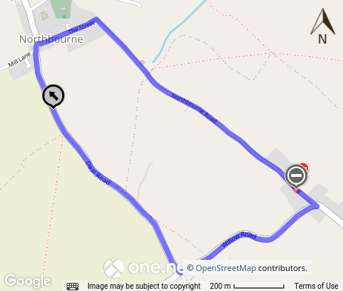
Map data © Google Terms of Use
This bulletin contains public information and can be forwarded to any other road users who may be affected. Every care is taken to ensure the accuracy of the information, but no liability can be accepted for any changes or errors.
Road names are taken from the National Street Gazetteer, which can be viewed on one.network, with alternative names given where known.

For details of roadworks, please see One.Network

Regards,
Streetworks East Team
03000 418181 (9am - 5pm)
03000 419191 (5pm - 9am)

