White Cliffs Walking Festival 25th to the 30th August

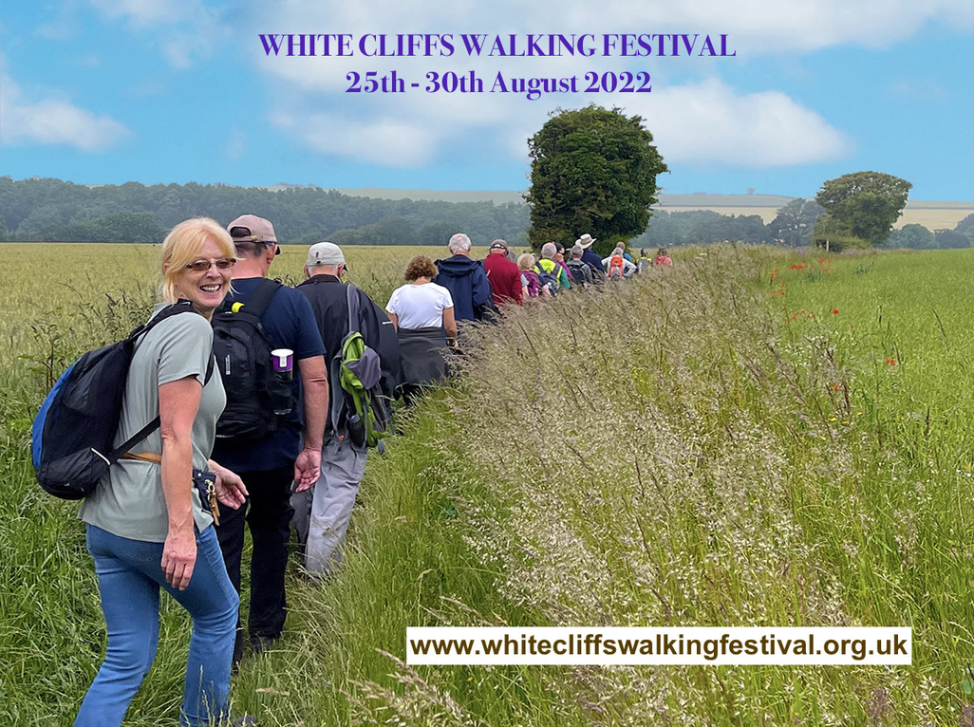
The White Cliffs Walking Festival has been organised to promote walking as an enjoyable, interesting and healthy pastime, to include walks for a wide variety of people, in fact anyone who enjoys a walk and enjoys the beautiful countryside we live in. There are over 30 walks across the district, some short, some long, some in between. We aim to make it more than a walk…an experience. Each walk has a theme to add interest, whether it is something to do with the area's history, or heritage, archaeology, and/or to experience some of the beautiful countryside and scenery. Some walks may start, or finish or pass through your Parish, but also many other walks are within easy reach. Our walks are mostly free, some include a small fee for a guide or special visit.
We sincerely hope people from your parish community become aware of, and come along on some of the walks. These are very friendly and sociable occasions, walking at a pace to suit the individual. Walk leaders are highly experienced and knowledgeable. Booking for the walks will be taken from the 20th of June 2022. via our website www.whitecliffswalkingfestival.org.uk

